**Administrator Manual**

The administrator is able to do everywhere that a standard user can do. Please refer to the User Manual document for that workflow. You can register an account the same way as a user can, however at the drop down tab, select Admin.



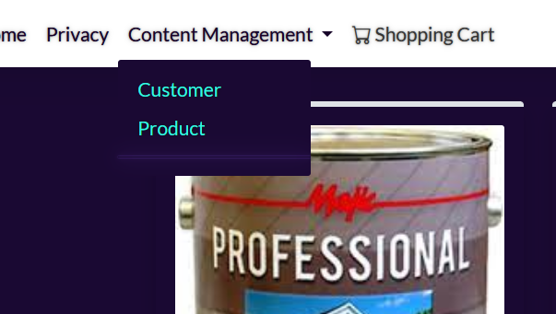 As you can see, the admin account has access to additional powers.

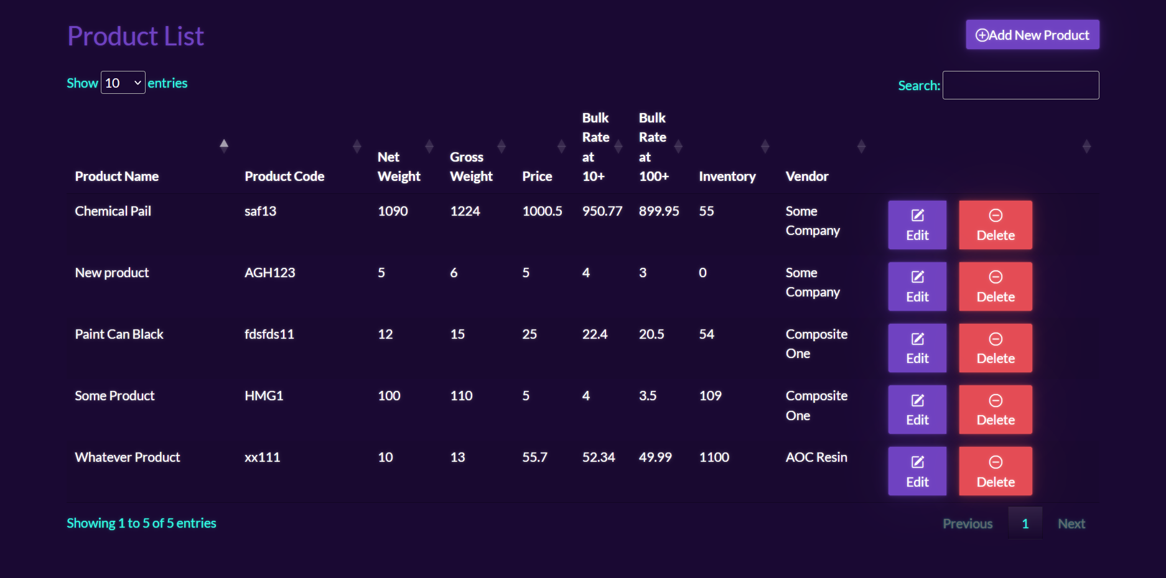 The administrator has the ability to perform CRUD operations. You can add new products on the top left. Editing and deleting is also available in the rows corresponding to the product.

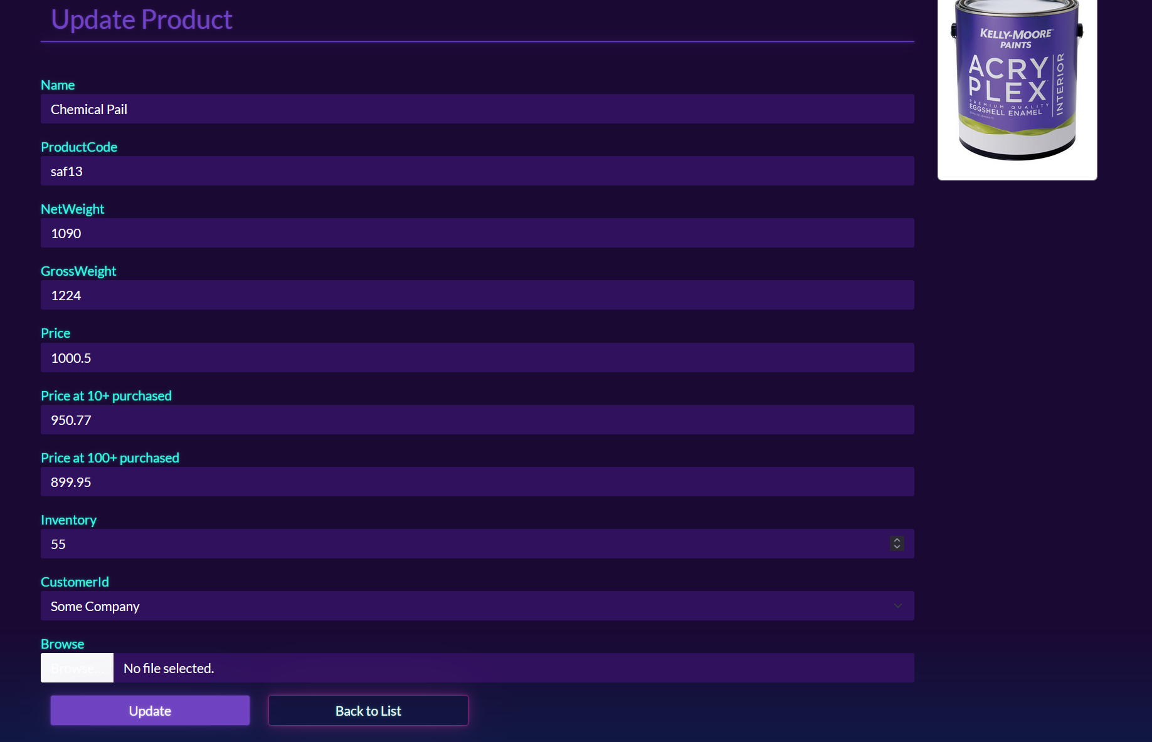 This is an example of the page where you can edit a product.

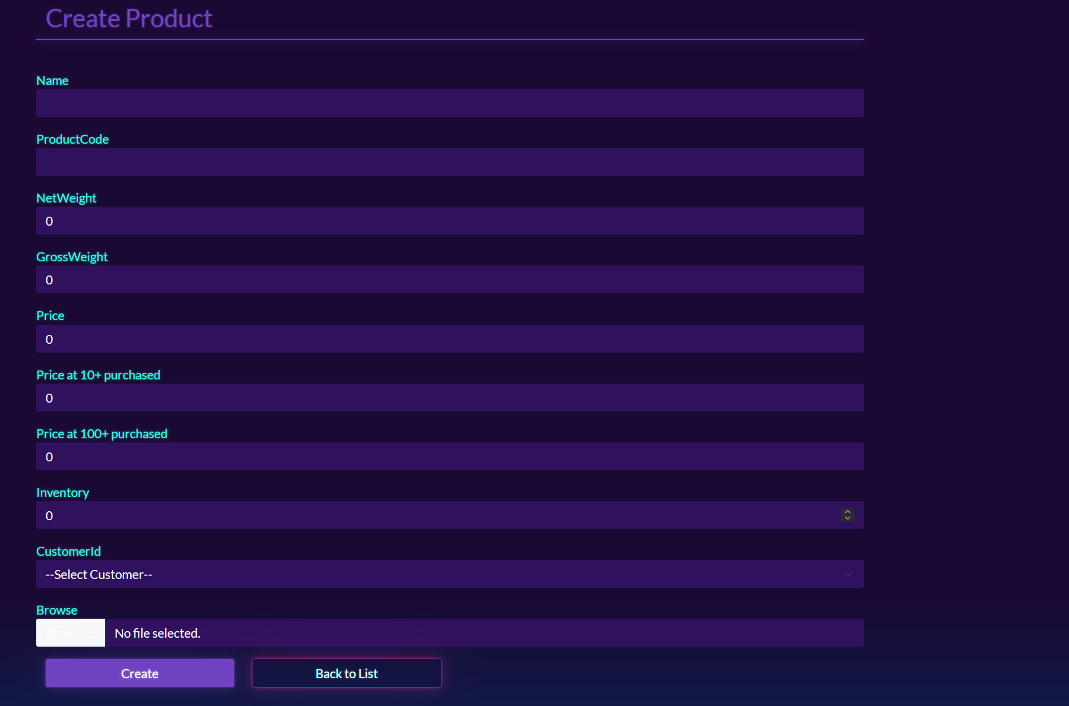 This is an example of the page for creating products. These pages also exist for creating customer.

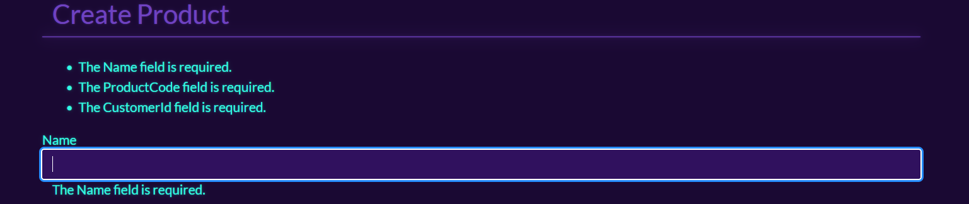 Furthermore, as you can see, there exists custom validations to ensure data integrity.